**Criteria for analysis**1) Number of comparisons (Total time taken depends upon comparisons)  
2) Number of swaps  
3) Adaptive  
4) Stable  
5) Extra Memory

Adaptive 🡪 If any sorting algorithm takes minimum time/less time over an already sorted list, then that algorithm is adaptive.

Stable 🡪 If there are any duplicate elements in the 1st sorted list, then their order must be preserved in the 2nd sorted list also. These are used in data-bases.  
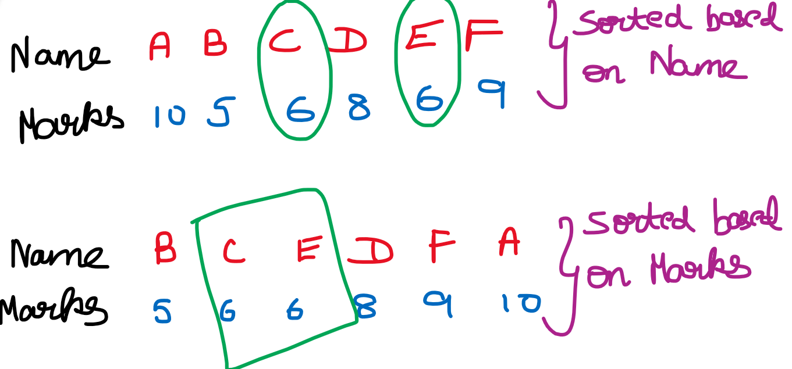

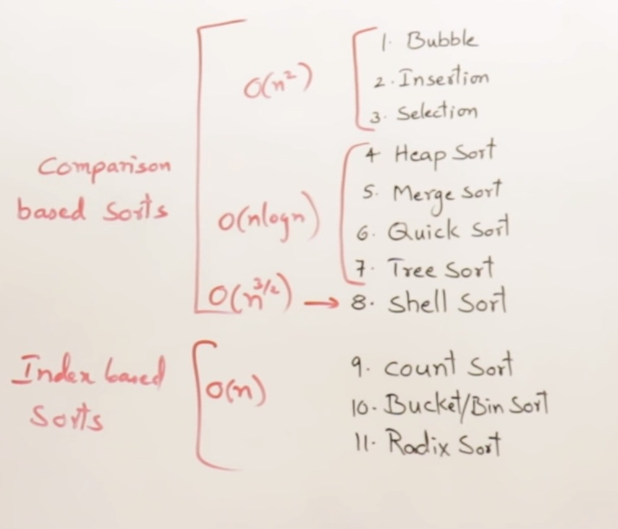

**Bubble Sort**

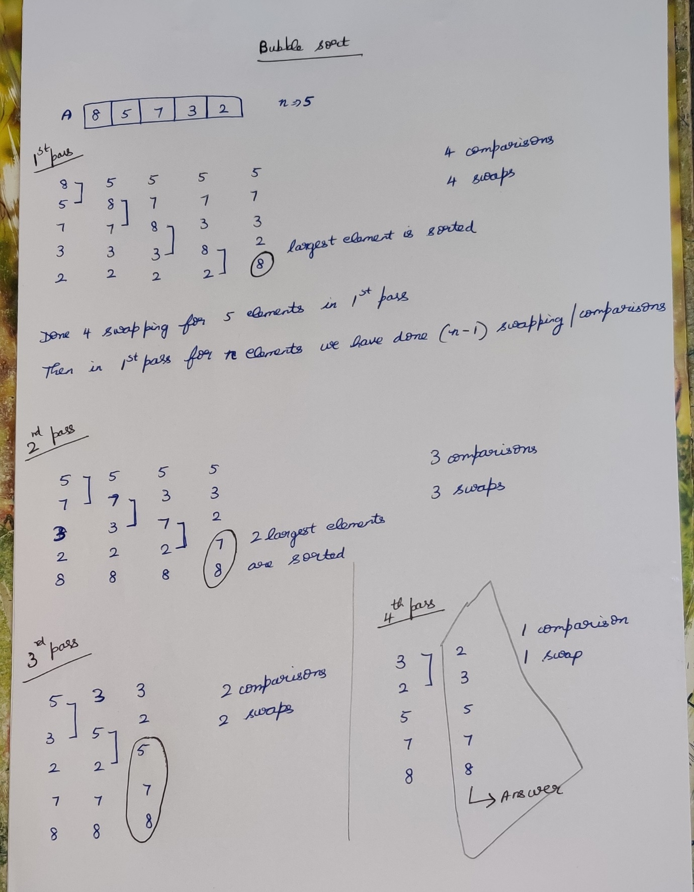

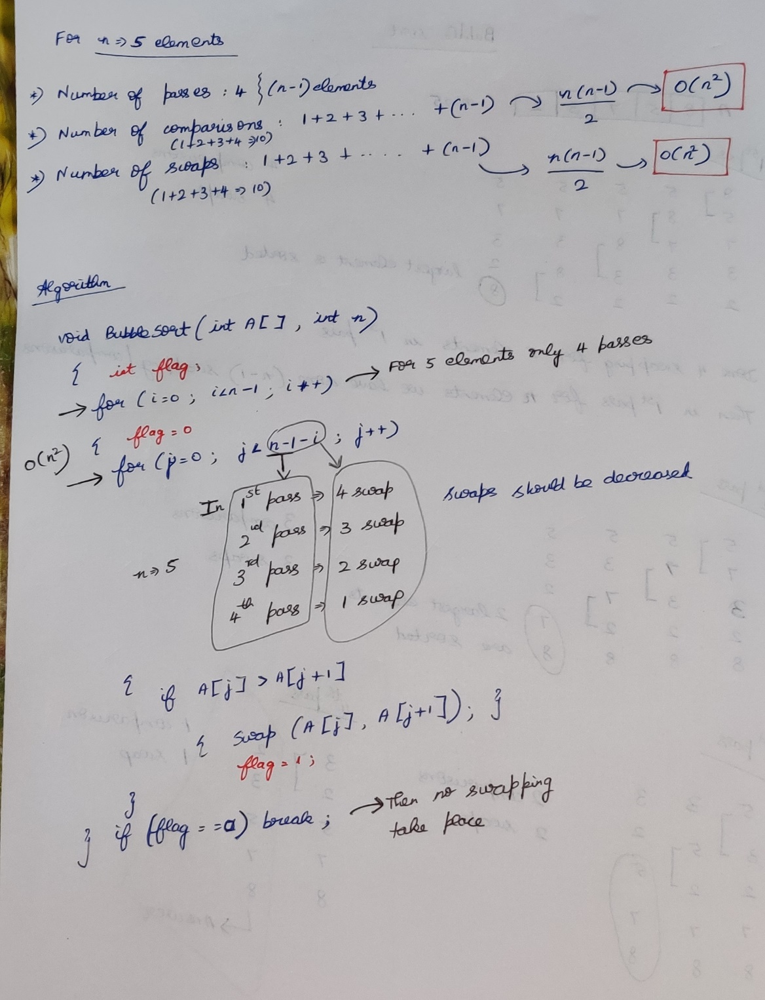  
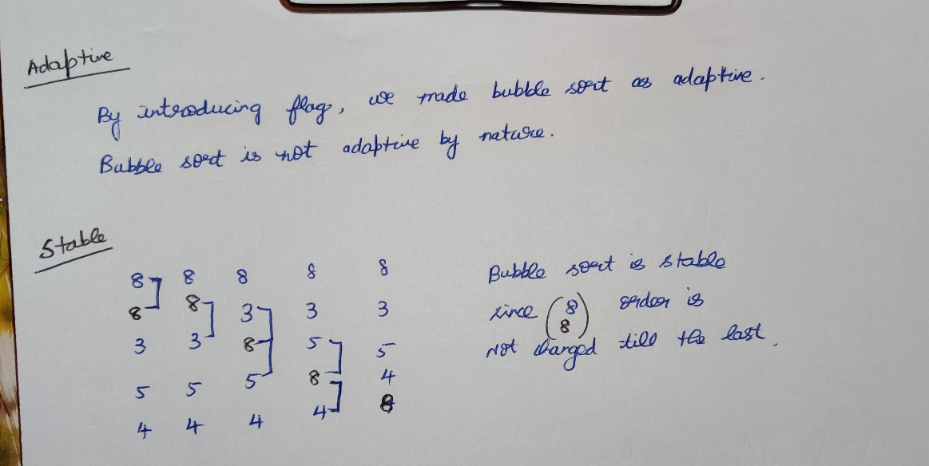

**Insertion Sort**

Inserting a new element in a sorted array that too in sorted position.

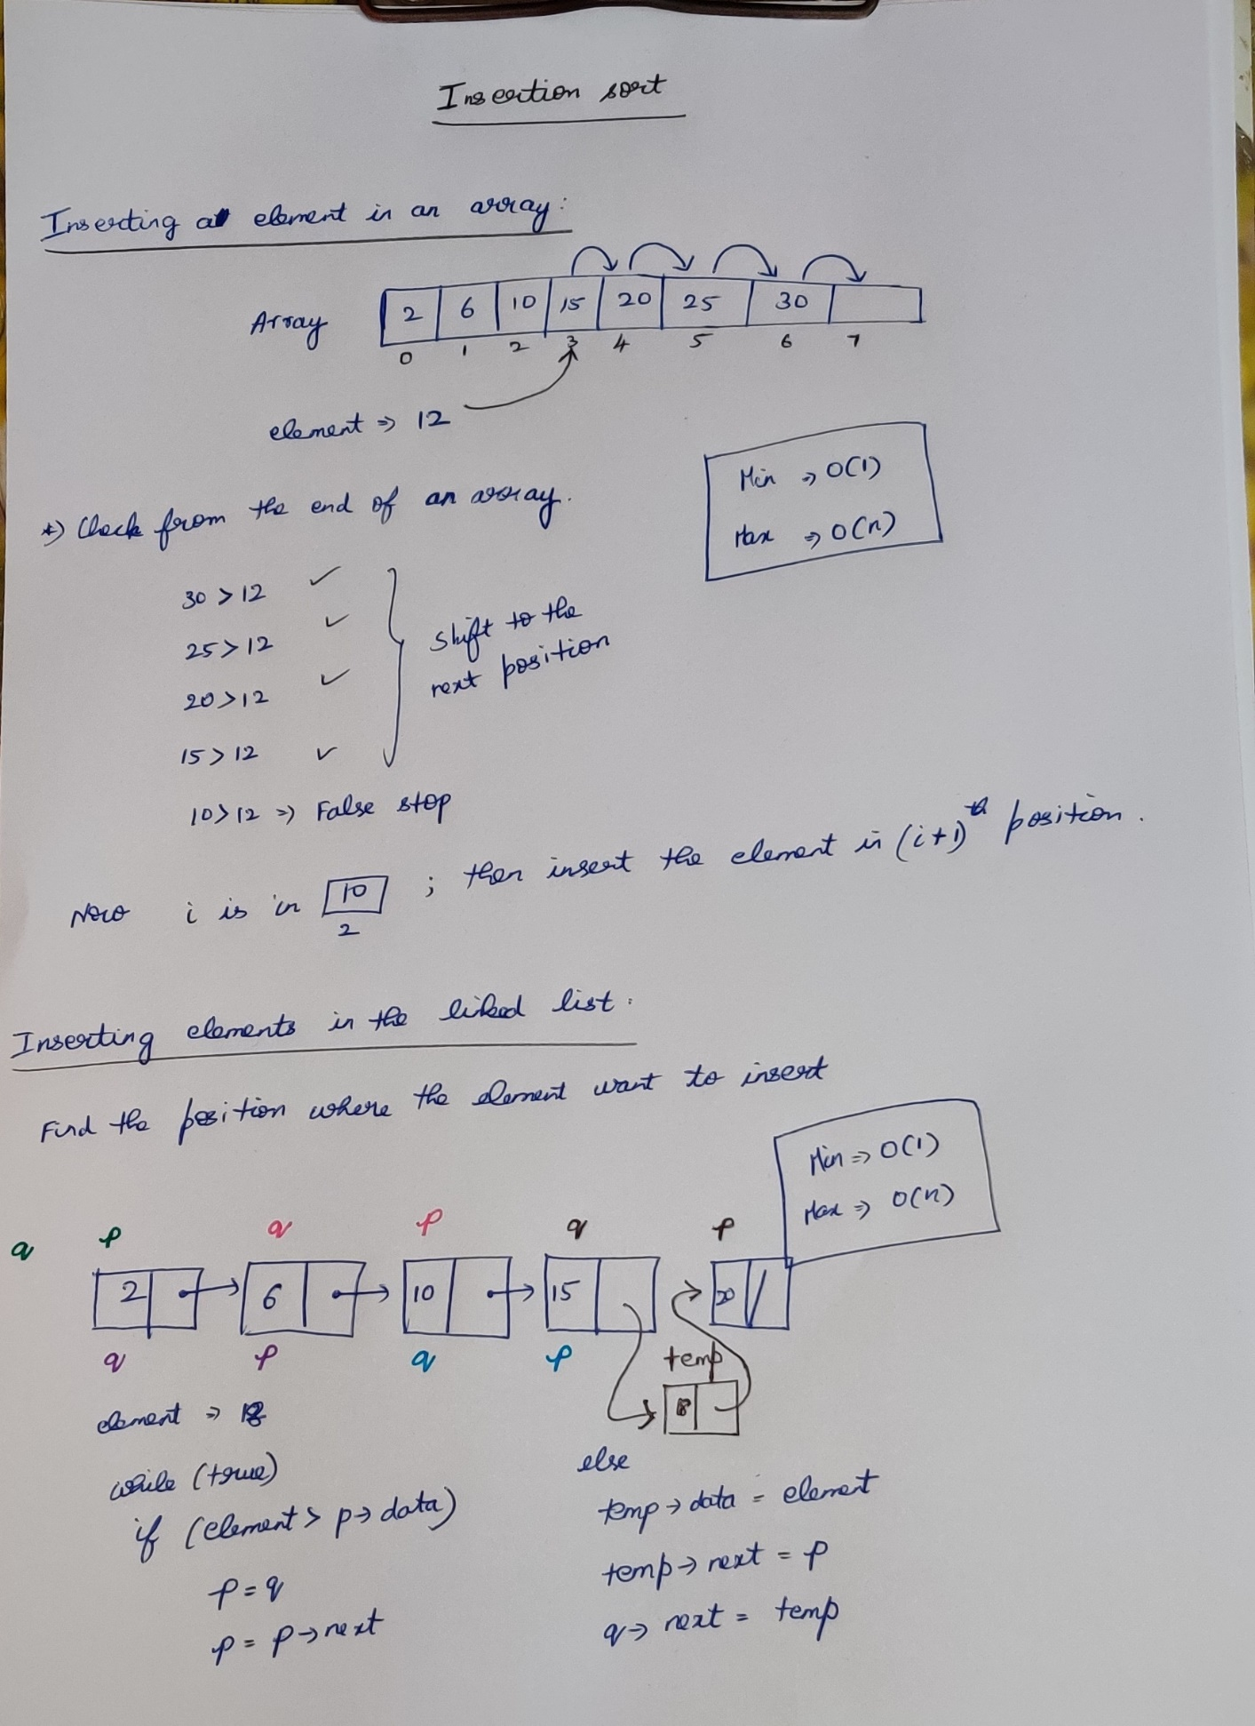

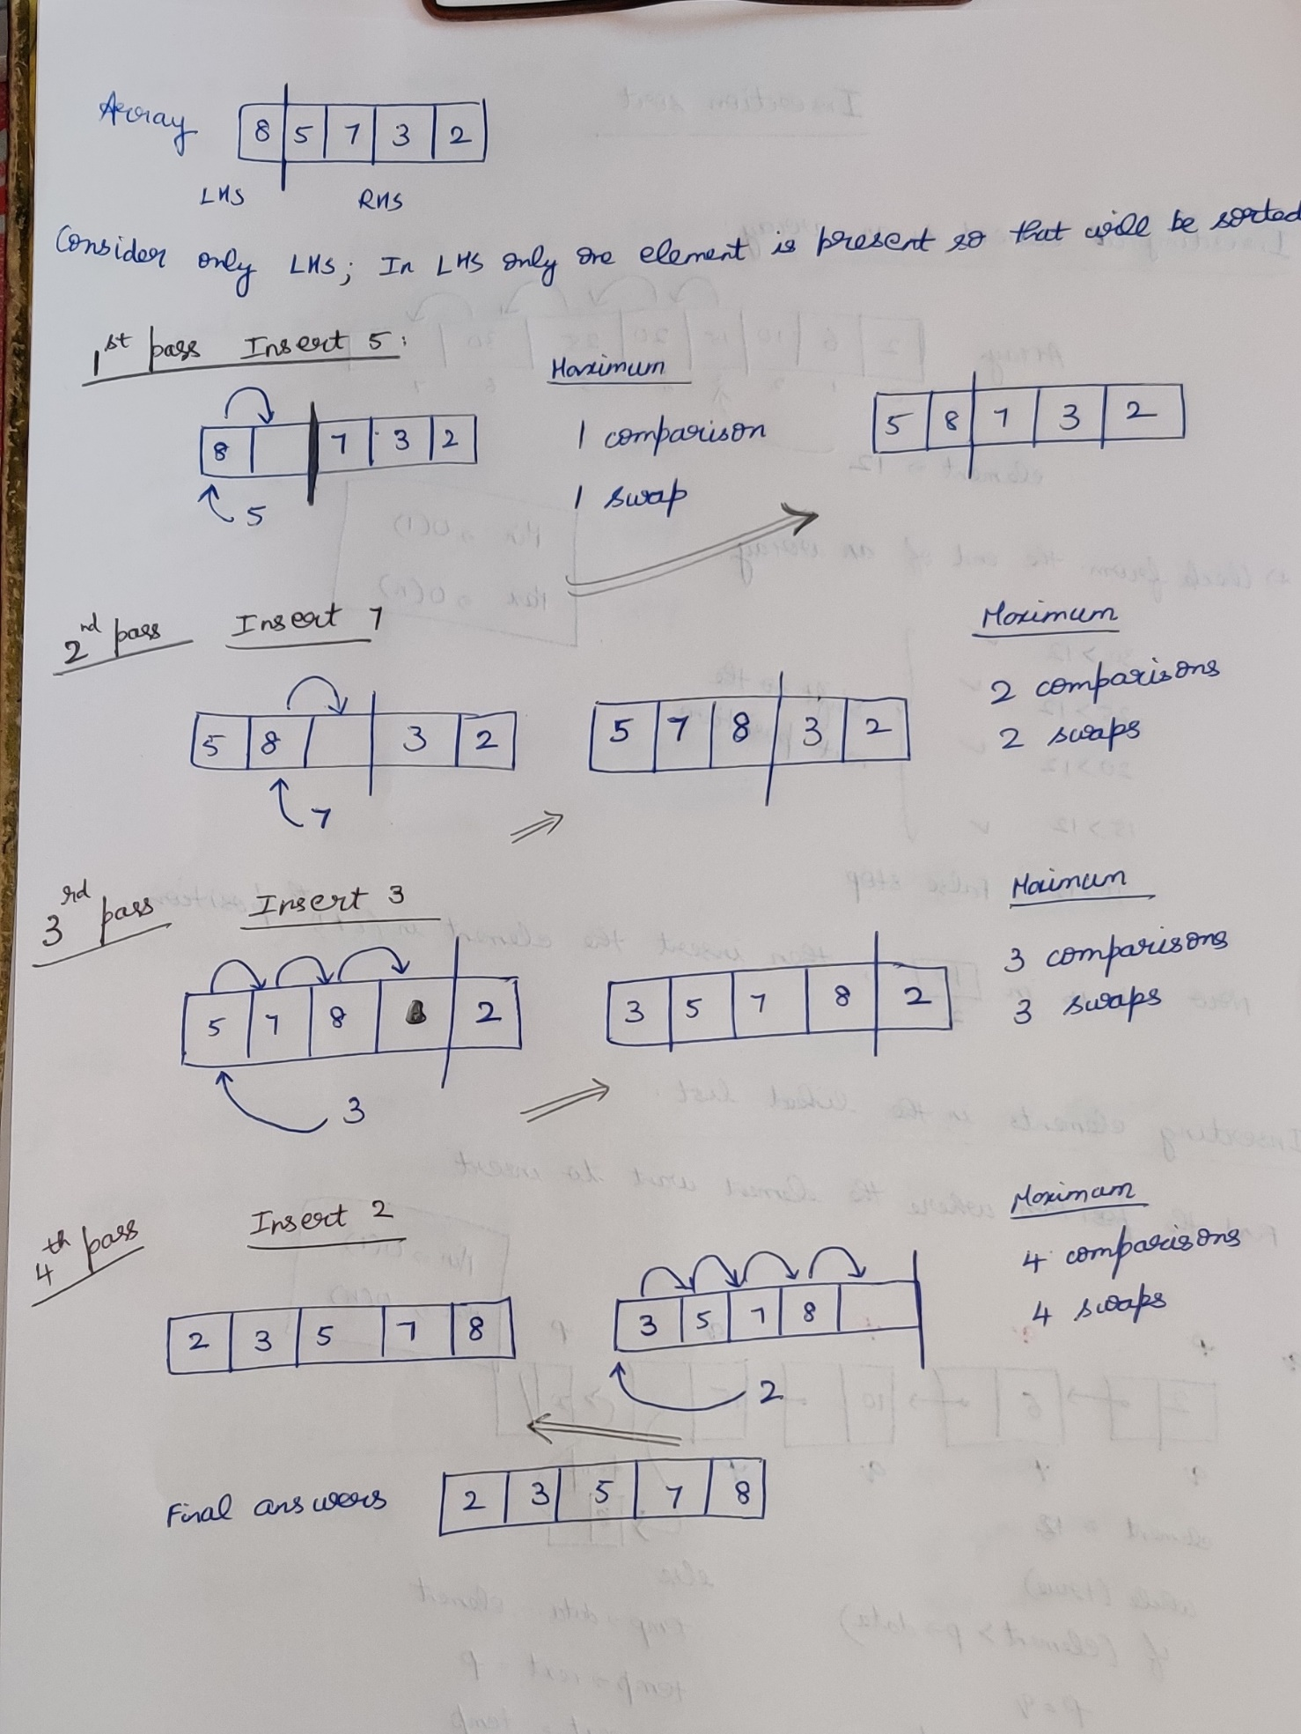

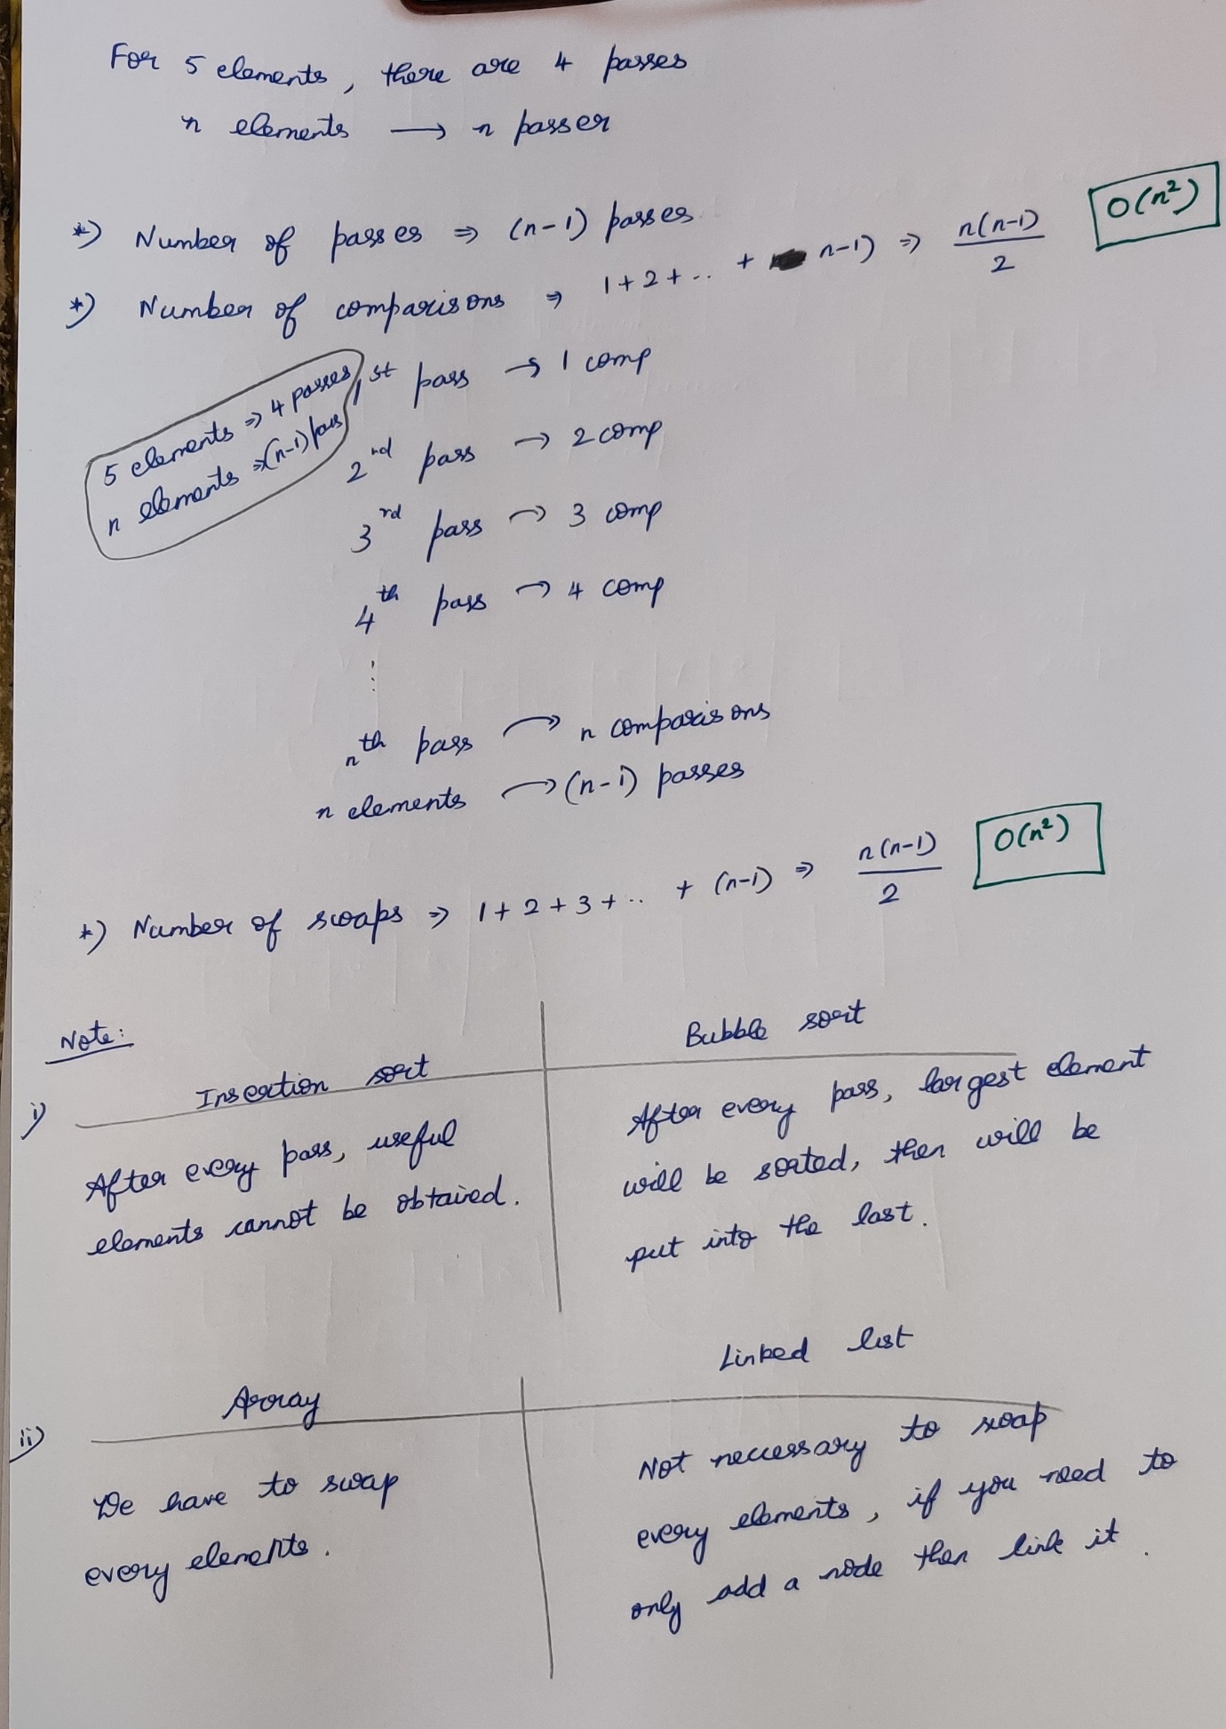

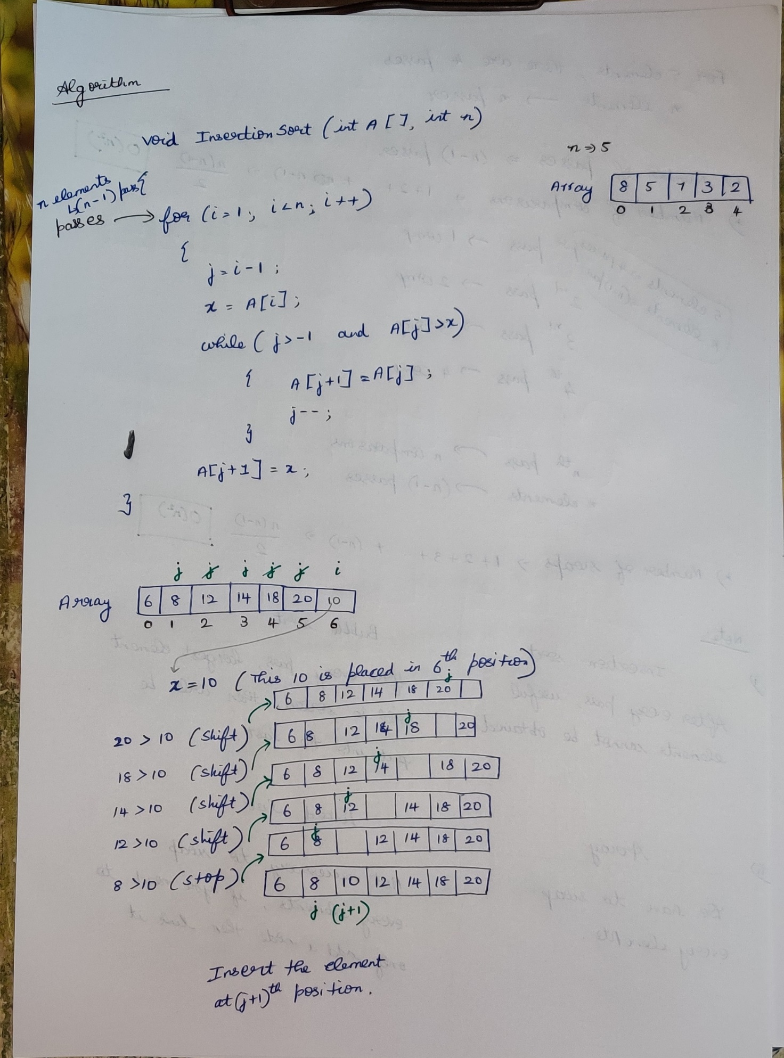

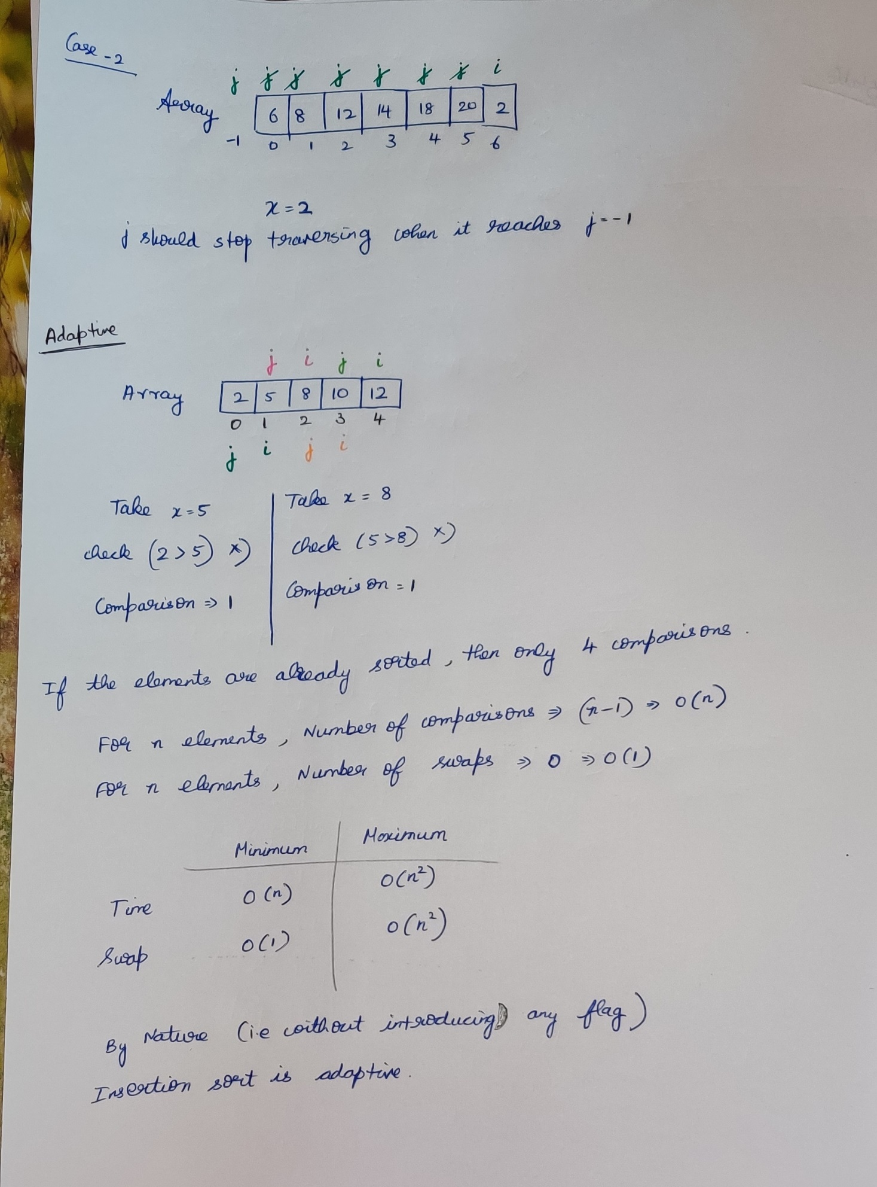

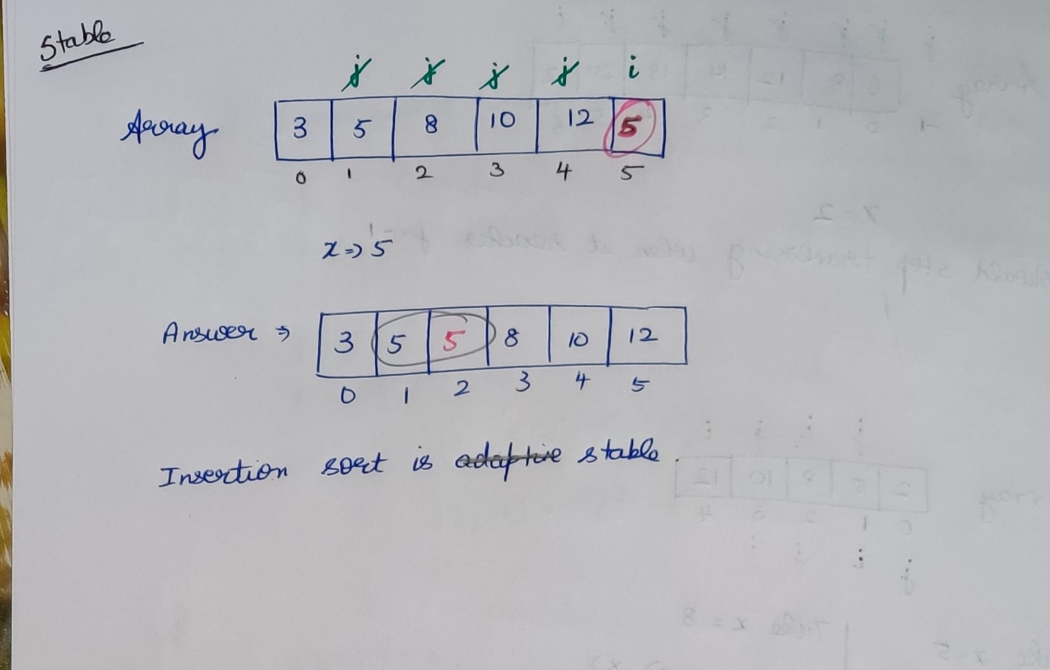

**Difference between bubble and insertion sort**

